Software Architecture Design

Architecture Pattern Selection
Architecture of the KriGo automobile renting portal specifies how the overall structure of the system is organized and defines roles of the different components as well as relationships between them. Choice of architecture pattern is a critical step of the design process since this choice affects such important aspects as scalability, maintainability, security, performance and extensibility of the system.
Considering the requirements of the KriGo system in terms of user authentication, vehicle administration, reservation, payment, AI recommendation services, AI chatbot, analytics generation and mobile app integration the most suitable architecture style to be used is Layered Architecture (N-Tier Architecture) combined with Service Oriented Design.
With help of this architecture pattern the application is split into autonomous layers with distinct responsibility. This approach increases modularity, simplifies maintenance, allows collaboration and possible integration of other services.

Selected Architecture Pattern
The KriGo portal utilizes Layered (Three Tier) Architecture with the following main layers:
- Presentation Layer;
- Business Logic Layer;
- Data Access Layer;
- Database Layer.
Additionally, there are special services such as Artificial Intelligence, Payment Gateway integration, Notifications and Locations which are created as standalone services working with the business layer.
The architecture of the system has features of low coupling and high cohesion and this allows evolving individual layers separately without disturbing the whole system.
Architecture Justification
Layered Architecture has been selected for achieving a clean separation of concerns in terms of user interface, business logic, data storage, and other infrastructural services. Such a separation makes maintenance of the software easier through reduction in the dependency of one component on another and modifications within the same layer without affecting other layers. In addition, the architecture is capable of supporting various clients such as web clients, mobile clients, and desktop clients, along with integration with external payment gateway services, artificial intelligence services, cloud storage services, and notification services.

Logical Architecture
The logical architecture organizes the KriGo platform into six principal layers, each responsible for a distinct aspect of system functionality.

Presentation Layer
Presentation Layer acts as an interface used by the users in interacting with the system. The presentation layer handles information display, collects the user input, and communicates with the business layer through secure APIs.
The layer does not contain any business logic, thus ensuring that the user interface elements remain independent of application processing.

The Presentation Layer includes:
- Web application for Customers (Next.js)
- Mobile Application (React Native)
- Desktop application for administration (Electron.js)
The main functions of the layer include displaying views of the application, checking basic input data of the user, sending request to the server, and displaying responses from the business layer.

Business Layer
The Business Layer is considered the main part of the KriGo software suite. It incorporates business rules of the application and coordinates interaction between users, databases, and third-party systems.
- Developed using NestJS, the layer controls all processes, which include:
- User authentication and authorization
- Management of vehicles and fleets
- Processing of reservations
- Payment management
- Verification of agencies
- Customers' reviews
- Handling disputes
- Notifications management
- Generation of AI recommendations
- Analytics creation
Through the aggregation of business rules, the architecture ensures uniform behavior of all client applications.

Data Access Layer
Data Access Layer acts as a mediator between business logic and database management systems. It encapsulates the operations on databases from other parts of the software, which makes possible for any changes in the persistence layer to not affect other layers.
This layer is implemented using Prisma ORM, which provides:
- Object-relational mapping.
- Repository implementation.
- CRUD operations.
- Query optimization.

Data Layer
The Data Layer is responsible for persistent storage and retrieval of application data.
Multiple storage technologies are employed according to the nature of the stored information.
Technology | Purpose
PostgreSQL | Relational business data
pgvector | AI embedding storage and semantic search
Neo4j | Graph-based recommendation relationships
Redis | Cache, temporary sessions, and reservation locking
Amazon S3 / Cloudflare R2 | Document and image storage
Together, these technologies provide efficient storage for transactional, analytical, and AI-related data.

Infrastructure Layer
Infrastructure Layer provides additional services which help to increase reliability, scalability, and productivity of the system.
The main responsibilities of the Infrastructure layer include asynchronous communications, background jobs execution, file storage, and integration with other systems.
The main building blocks of the infrastructure include:
- RabbitMQ messaging server.
- BullMQ background jobs execution server.
- WebSockets server.
- Docker containerization.
- Cloud-based object storage for uploaded files.

Monitoring Layer
The Monitoring Layer offers uninterrupted oversight of the health and performance of the KriGo platform.
Monitoring services include the collection of application metrics, error detection, and generation of operational dashboards to assist in maintaining the reliability of the system.
Monitoring includes:
- Sentry for exception monitoring
- Prometheus for metric collection
- Grafana for visualization and dashboards

Architecture Communication
Requests from one architectural layer to another follow a strict request-response pattern. The client application makes the request via an HTTPS or WebSocket connection, which is then handled by the Business Layer. The Business Layer executes the business logic and involves the Data Access Layer if the data must be persisted. The Data Access Layer connects to the relevant database and sends the required information to the Business Layer, which creates a response for the Presentation Layer.
There are certain actions such as notifications delivery, analytics generation, AI models updating, and emails sending, which are performed asynchronously using RabbitMQ and BullMQ. This solution helps improve response time and boost application performance.
The communication pattern can be represented as follows:
- Presentation Layer -> Business Layer -> Data Access Layer -> Data Layer
Asynchronous operations take place in the following way:
- Business Layer -> Message Queue -> Background Workers -> External Services

External Systems Integration
KriGo interacts with different external systems to deliver extended services that complement the main ones.
Algeria Post Edahabia Payment Gateway provides online payment processing capabilities for vehicle booking. The artificial intelligence services offer personal recommendations and conversational capabilities to the user. Cloud Storage services like Amazon S3 or Cloudflare R2 save the uploaded documents and vehicle pictures without expanding the database. The mapping services help conduct location-based searching and navigate through branches. The monitoring services continuously monitor the application's performance and health.
All integrations with these services are implemented using separate service modules, allowing them to be changed independently of the rest of the application's parts.

Architectural Design Principles
The design of KriGo platform has been done in line with common software engineering principles.
Separation of Concerns is provided by giving each layer specific concerns, which helps in minimizing interdependence and maintainability.
High Cohesion is ensured by having a clearly specified set of responsibilities for each module.
Low Coupling is provided by minimizing the dependence among components, allowing modules to evolve independently.
Scalability has been ensured by having modular design of services, asynchronous execution and using databases with good scalability.
Security has been ensured through use of role based access, encryption of authentication and safe API communications and database access.
Reliability is provided through centralized error handling, transaction management, background execution and logging.

Architectural View
Figure illustrates the architectural view of the KriGo framework. The architecture is made up of six layers that exchange information in a sequential manner while maintaining a well-defined separation of concerns. Applications communicate only with the Presentation layer, which sends the messages to the Business layer. The Business layer controls the application business logic, retrieves persistent data from the Data Access Layer, and interacts with necessary infrastructure as required.

Such a layered structure ensures efficiency in communications between software modules.
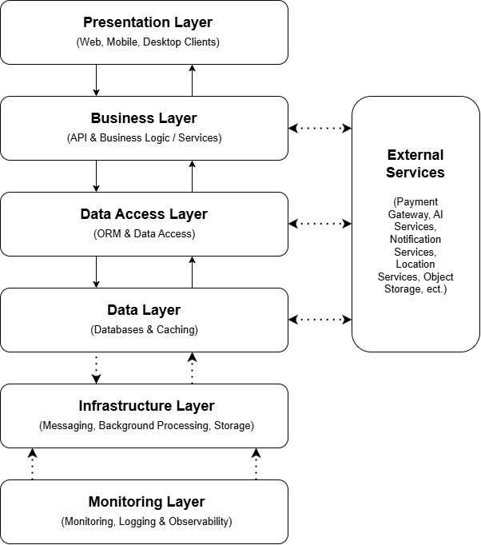
Figure 1 - High-Level Layered Architecture of the KriGo Vehicle Rental Platform

